Tackling Malaria: Synthesis, Biological Evaluation and In Silico analysis of Dihydroxyindenoimidazolone (DHI) against Plasmodium berghei in Murine model
Materials and methods
Synthesis
All the chemicals and the reagents used were of synthetic and analytical grades. Aromatic aldehyde was added to an equimolar amount of the thiosemizarbazide in a 250 mL beeaker and 10 mL of ethanol added as solvent. 3 drops of conc HCl was added for catalysis and the resulting mixture was microwave irradiated for 60 secs after which the resulting clear solution was left to stand on the bench for 24 hours. The solid precipate formed after leaving to stand was filtered, weighed and the melting point determined. The synthesized thiosemicarbazones were submitted for spectroscopic analysis. The thiosemicarbazones were added to an equimolar amount of ninhydrin in acidified ethanol and stirred for 24 hours at room temperature (until all the ninhydrin reacted completely). The reaction was monitored using Thin Layer Chromatography. At the end of the reaction the reaction mixture was filtered to afford the yellow-orange coloured solid product which was air dried and the melting point determined. The synthesized compounds were submitted for spectroscopic analysis.

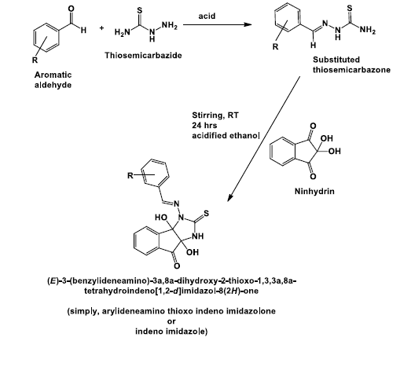
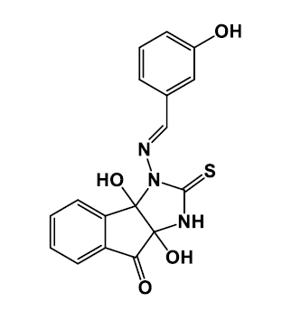
(E)-3a,8a-dihydroxy-3-((3-hydroxybenzylidene)amino)-2-thioxo-1,3,3a,8a-tetrahydroindeno[1,2- d]imidazol-8(2H)-one
Pharmacological studies
Anti-malarial activity test
Swiss albino mice, reared and bred in the animal house of the Department of Chemistry, Obafemi Awolowo University, Île-Ife were used for the experiment. The mice were acclimatized for five days to laboratory conditions prior to the experiment.
Malaria Parasite
The chloroquine-sensitive strain of Plasmodium berghei, NK-65, obtained from the Institute of Advanced Research and Training, University College Hospital, University of Ibadan was used for the experiment. The parasite was kept alive by intra-peritoneal passage in mice.
Determination of Acute Toxicity (LD₅₀)
Acute toxicity of the synthesized compounds was determined using the Lorke’s method (Lorkes, 1983). Nine mice were divided into three groups (A, B, and C). The three groups were administered orally with graded concentrations (10, 100, 1000 mg/kg respectively) of the compound in a single dose. The animals were closely monitored for 24 hours for any manifestation of toxicity.
Chemosuppressive Test
This test was used to assess the antimalarial activity of the synthesized compounds against the infected mice. The anti-plasmodial activity of the synthesized compounds was performed in four days suppressive standard test.
Innoculation with Parasite
Swiss albino mouse weighing 18-20 g previously infected with Plasmodium parasite (parasitemia level of 40 %) was used as donor. The donor mouse was sacrificed with chloroform anesthesia and blood was collected into sterile disposable syringe by cardiac puncture method. The desired volume of blood collected from the donor mouse was appropriately diluted with saline based on the calculated percentage parasitemia of the donor mouse. Each experimental mouse was inoculated intraperitoneally with 0.2 ml of the infected blood.
Grouping and Dosing of Animals
Swiss albino mice were randomly divided into five groups (with five mice per group). Three groups were assigned as test groups while the other two groups were used as control (positive and negative) groups. Different doses of the synthesized compounds were dissolved in olive oil. The animals in the test groups were administered doses of 5, 10 and 25 mg/kg of the compounds respectively while the control groups were administered with 10 mg/kg chloroquine (reference drug, positive control) and 0.2 ml of vehicle (olive oil) for the negative control group. The test (synthesized) compounds were administered to the animals for four consecutive days along with chloroquine and olive oil for positive control and negative control respectively.

Suppressive Test
The chemosuppressive test was evaluated using Knight and Peters (1980) method against mice infected with chloroquine sensitive P. berghei and was carried out with two test compounds (40 animals). The mice were infected on the first day of the experiment and 24 hours post infection, the experimental mice were distributed into groups as described in the grouping and dosing of animals section above. Drug administration was carried out consecutively for four days and percentage parasitemia was determined.
Determination of Parasitemia
The determination of parasitemia was carried out on the fifth day (120 hours post infection). Thin blood smear of each of the mouse was done by taking a drop of blood from a tiny cut to the tail of the animal on to a microscope glass slide and spreading it thinly with the aid of another slide. The smear was air-dried and then fixed with methanol. The glass slide was allowed to dry and was then stained with Giemsa solution (diluted 1:10 with phosphate buffered saline). The stain was sufficiently poured on each of the slide and allowed to stand for 1 hour, decanted, slowly rinsed with water and dried. The slides were viewed under the light microscope (with 100-x magnification, oil immersion) individually. The parasitemia level was determined by counting the number of parasitized red blood cells out of the total red blood cell in random fields of microscope. The percentage chemo suppression of parasitemia for each dose level was calculated by comparing the percentage parasitemia of the controls (positive and negative control) with those of treated mice using the modified Peters and Robinson formula.
% Parasitemia = $\frac{Parasitizedbloodcells}{Total red bloodcells }X100$
% Chemosuppression = $\frac{\left(A-B\right)}{A}X100$
Where “A” is the average parasitemia for the negative control group and “B” is the average parasitemia for the test compounds.
Determination of Mean Survival Time
Mortality was monitored daily and the number of days from the time of inoculation of the parasite up to death was recorded for each mouse in the treatment and control groups throughout the follow-up period. The mean survival time (MST) for each group was calculated using the following formula (Mengiste et al., 2012).
MST= Sum of survival time (days) of all mice in a group ÷ Total number of mice in that group

Results

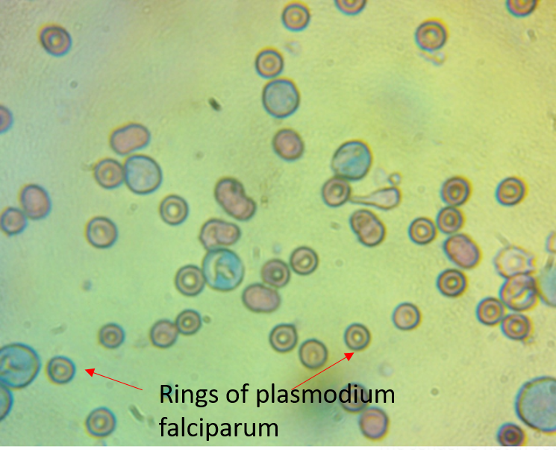
Figure 1: Representative photomicrograph of blood smear of infected mice stained with Giemsa stain.

Figure 2: The parasitemia levels in mice infected with Plasmodium berghei and treated with different doses of Chloroquine and Dihydroxyindenoimidazolone (DHI). Negative control represents mice that were infected but not treated. Chloroquine was used as the positive control at a dose of 10 mg/kg, while DHI was tested at doses of 5, 10, and 25 mg/kg. Parasitemia levels were measured on day 5 post-infection. Error bars represent standard deviation (SD) and the p-value was determined by one-way ANOVA followed by Tukey's post-hoc test. Statistical significance was indicated by *p < 0.05 compared to the negative control, and #p < 0.05 compared to the positive control (Chloroquine).
Inference: The results demonstrate that treatment with Chloroquine and DHI significantly reduced parasitemia levels compared to the negative control group (*p < 0.05). Among the DHI-treated groups, the highest dose (25 mg/kg) showed the most significant reduction in parasitemia levels compared to the positive control group (#p < 0.05). The p-value indicates that the observed differences in parasitemia levels between the treatment groups and the negative control or positive control are statistically significant.
The results indicate that both Chloroquine and Dihydroxyindenoimidazolone (DHI) are effective at reducing parasitemia levels in mice infected with Plasmodium berghei. The highest dose of DHI (25 mg/kg) was found to be the most effective at reducing parasitemia levels, as it showed a significant reduction compared to both the negative control and the positive control (Chloroquine) groups. These findings suggest that DHI has potential as an alternative or complementary treatment for malaria. However, further studies are needed to determine the safety and efficacy of DHI in humans.

Figure 3: Comparative Efficacy of Chloroquine and Dihydroxyindenoimidazolone at Different Doses Against Plasmodium berghei in Mice. The graph shows the percent chemosuppression of Plasmodium berghei in mice treated with Chloroquine and Dihydroxyindenoimidazolone (DHI) at different doses. Data were mean value of chemosuppression calculated as stated in the method section
Interpretation: Treatment with both Chloroquine and DHI at all doses tested resulted in reduction in parasitemia levels compared to the negative control group. The highest dose of DHI (25 mg/kg) showed the highest level of chemosuppression (82.4%), which was significantly higher than the chemosuppression observed with Chloroquine (19.3%).
Inference: The present study demonstrates that DHI has significant chemosuppressive activity against Plasmodium berghei in mice. The highest dose of DHI tested (25 mg/kg) showed greater efficacy than Chloroquine, which is a commonly used drug for the treatment of malaria. These findings suggest that DHI has potential as an alternative or complementary treatment for malaria. However, further studies are needed to determine the safety and efficacy of DHI in humans, and to explore its mechanism of action.

Figure 4: The graph represents the percent parasitemia and percent chemosuppression in mice infected with malaria parasites and treated with different drugs. The groups include: (1) ctrl, which represents the negative control (infected control), (2) CQ, which represents Chloroquine (10 mg/kg), (3) dihydroxyindenoimidazolone at 5 mg/kg, (4) dihydroxyindenoimidazolone at 10 mg/kg, and (5) dihydroxyindenoimidazolone at 25 mg/kg. The control group had 17.1% parasitemia and 0% chemosuppression. Treatment with CQ at 10 mg/kg resulted in 19.3% chemosuppression, while treatment with dihydroxyindenoimidazolone at 5 mg/kg, 10 mg/kg, and 25 mg/kg led to 56.3%, 56.6%, and 82.4% chemosuppression, respectively. The corresponding percent parasitemia for each treatment was 14.4%, 7.5%, 7.3%, and 6.7%, respectively. These results demonstrate a dose-dependent relationship between the drugs and both parasitemia and chemosuppression in mice infected with malaria parasites.

Table 1: Suppressive Activity of DHI and survival time of P. berghei infected mice in the 4-day suppressive test.
groups | dose (D0−D3) (0.2 mL/(mouse OD oral)) D0-i.p. inoculation  (1 × 106 P. berghei-infected RBCs) | parasitemia (%), day 5 | chemosuppression  (%), day 5 | Mean survival time/days
G1 | infected control | 1.7
G2 | Chloroquine (10 mg/kg) | 1.4 | 19.3
G3 | DHI (5 mg/kg) | 0.7 | 56.3 | 19.25±1.34
G4 | DHI (10 mg/kg) | 0.7 | 56.6 | 16.75±4.58
G5 | DHI (25 mg/kg) | 0.3 | 82.4 | 25.57.36

Figure 5: Percent survival of Plasmodium Berghei infected mice treated with different concentrations (5, 10 and 25 mg/kg) of DHI

References
Mengiste, B., Makonnen, E., & Urga, K. (2012). In vivo antimalarial activity of Dodonaea Angustifolia seed extracts against Plasmodium berghei in mice model. Momona Ethiopian Journal of Science, 4(1), 47-63.
Knight, D. J., & Peters, W. (1980). The antimalarial activity of N-benzyloxydihydrotriazines: I. The activity of clociguanil (BRL 50216) against rodent malaria, and studies on its mode of action. Annals of Tropical Medicine & Parasitology, 74(4), 393-404.

